AC App Changes:

1. Allowing font styling – to enable using bold, italic or underline

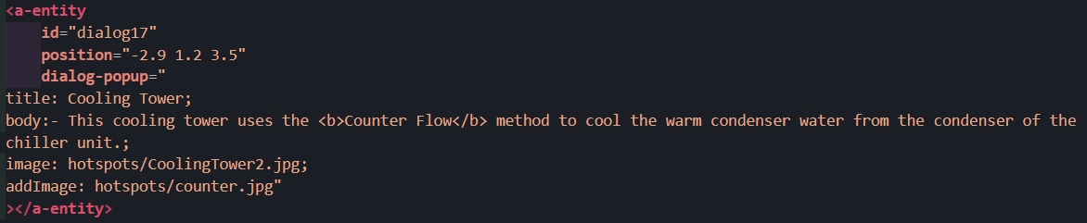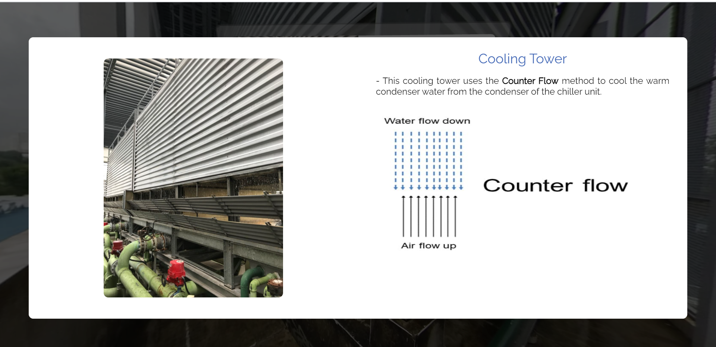

<b> bold

<i> italic

<u> underline

<s> strikethrough

<sup> superscript

<sub> subscript

1. Additional image parameter – addImage

To add a new image inside the close-up dialog box

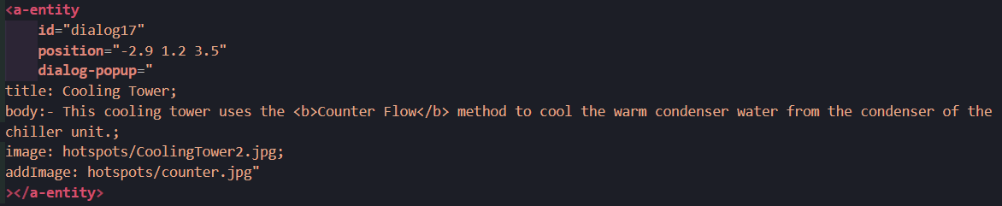

Enter addImage: (directories)/(image name) in the dialog-popup attribute.

1. To improve the transitioning between areas, a one second fade in effect is introduced
2. As a pointer to prompt user to click on the dialog popup to display the close-up dialog box, there is a GIF that resembles a cursor clicking on the dialog box.

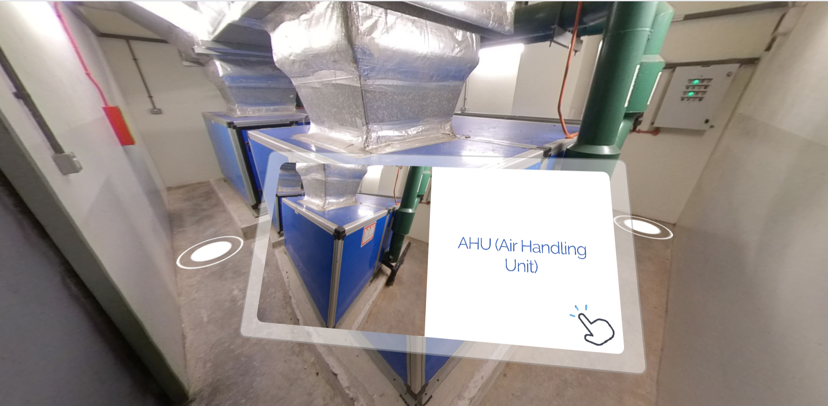

1. Responsive close-up dialog box

Desktop version:

Hover over the icon > Click on the dialog box > Close-up appears

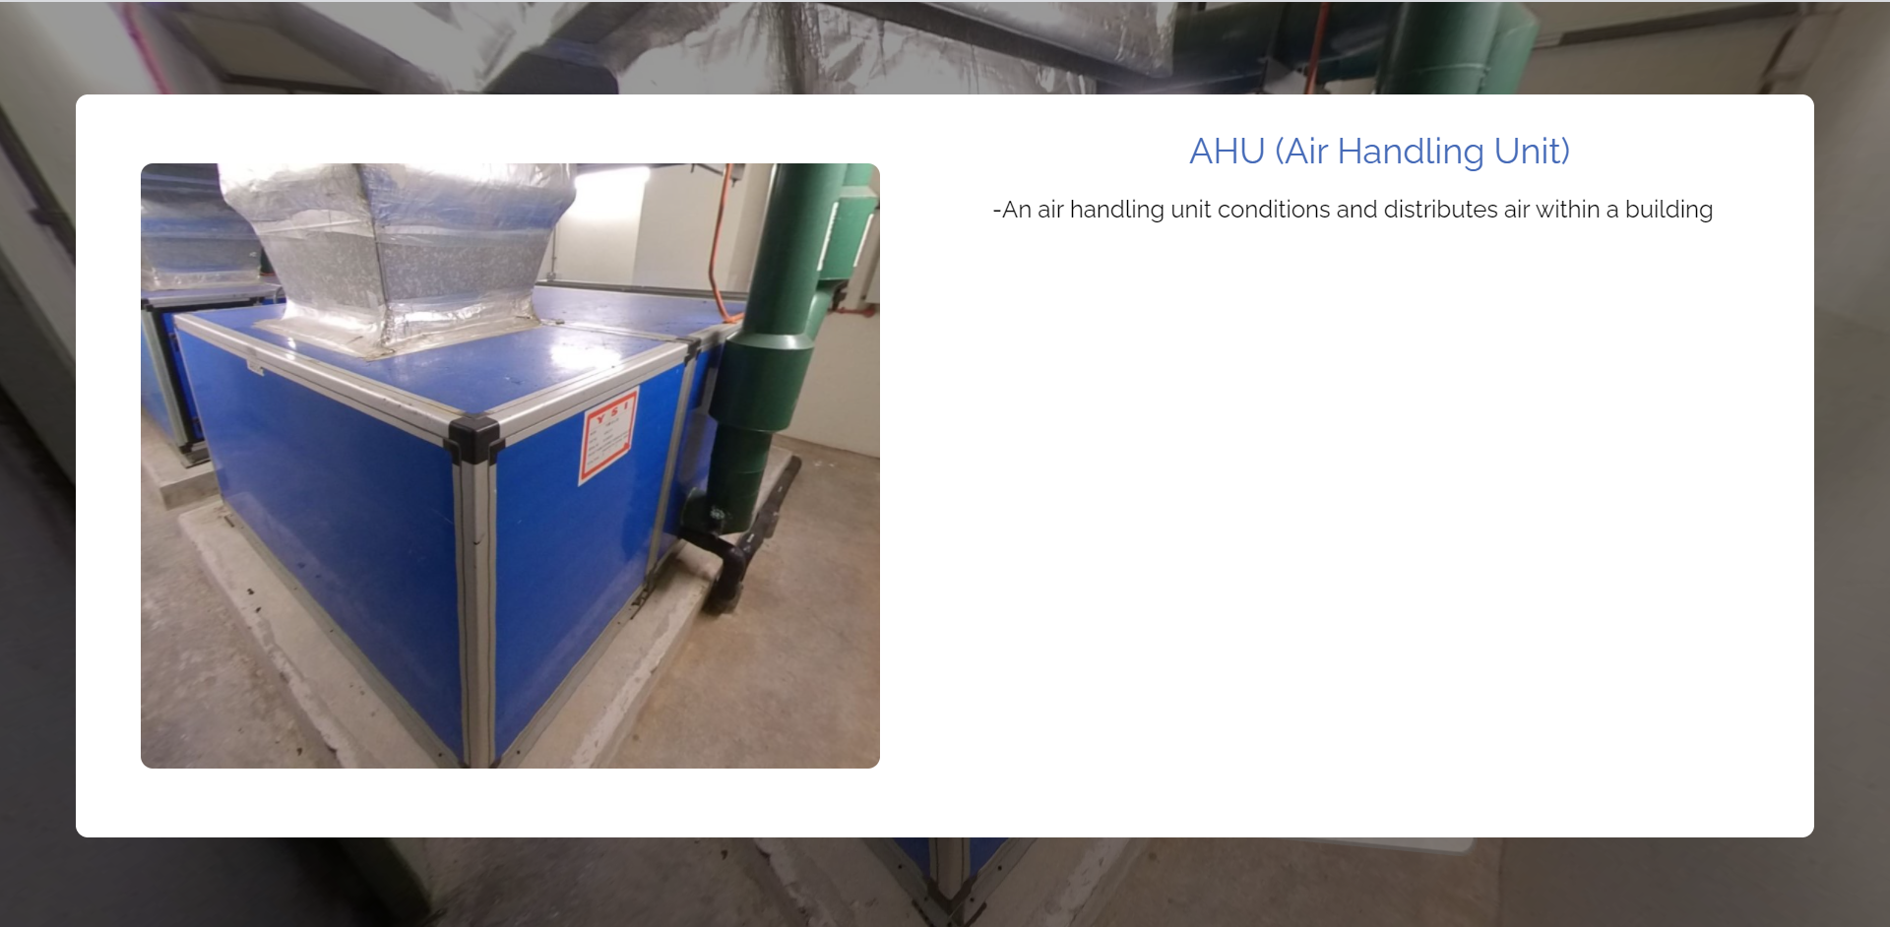

Mobile version:

Click on icon > Close-up appears

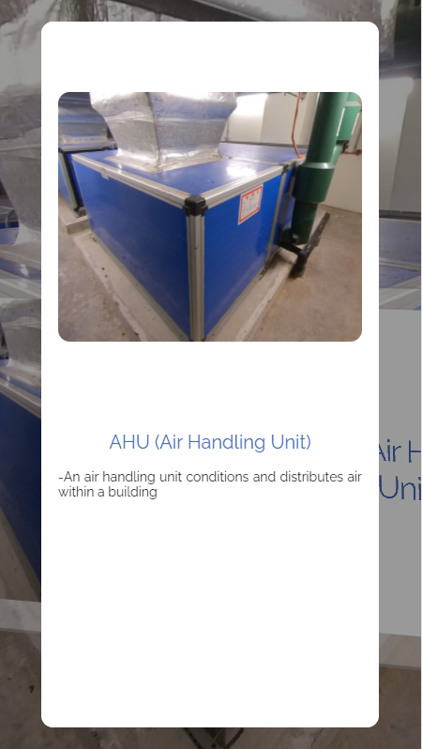

1. 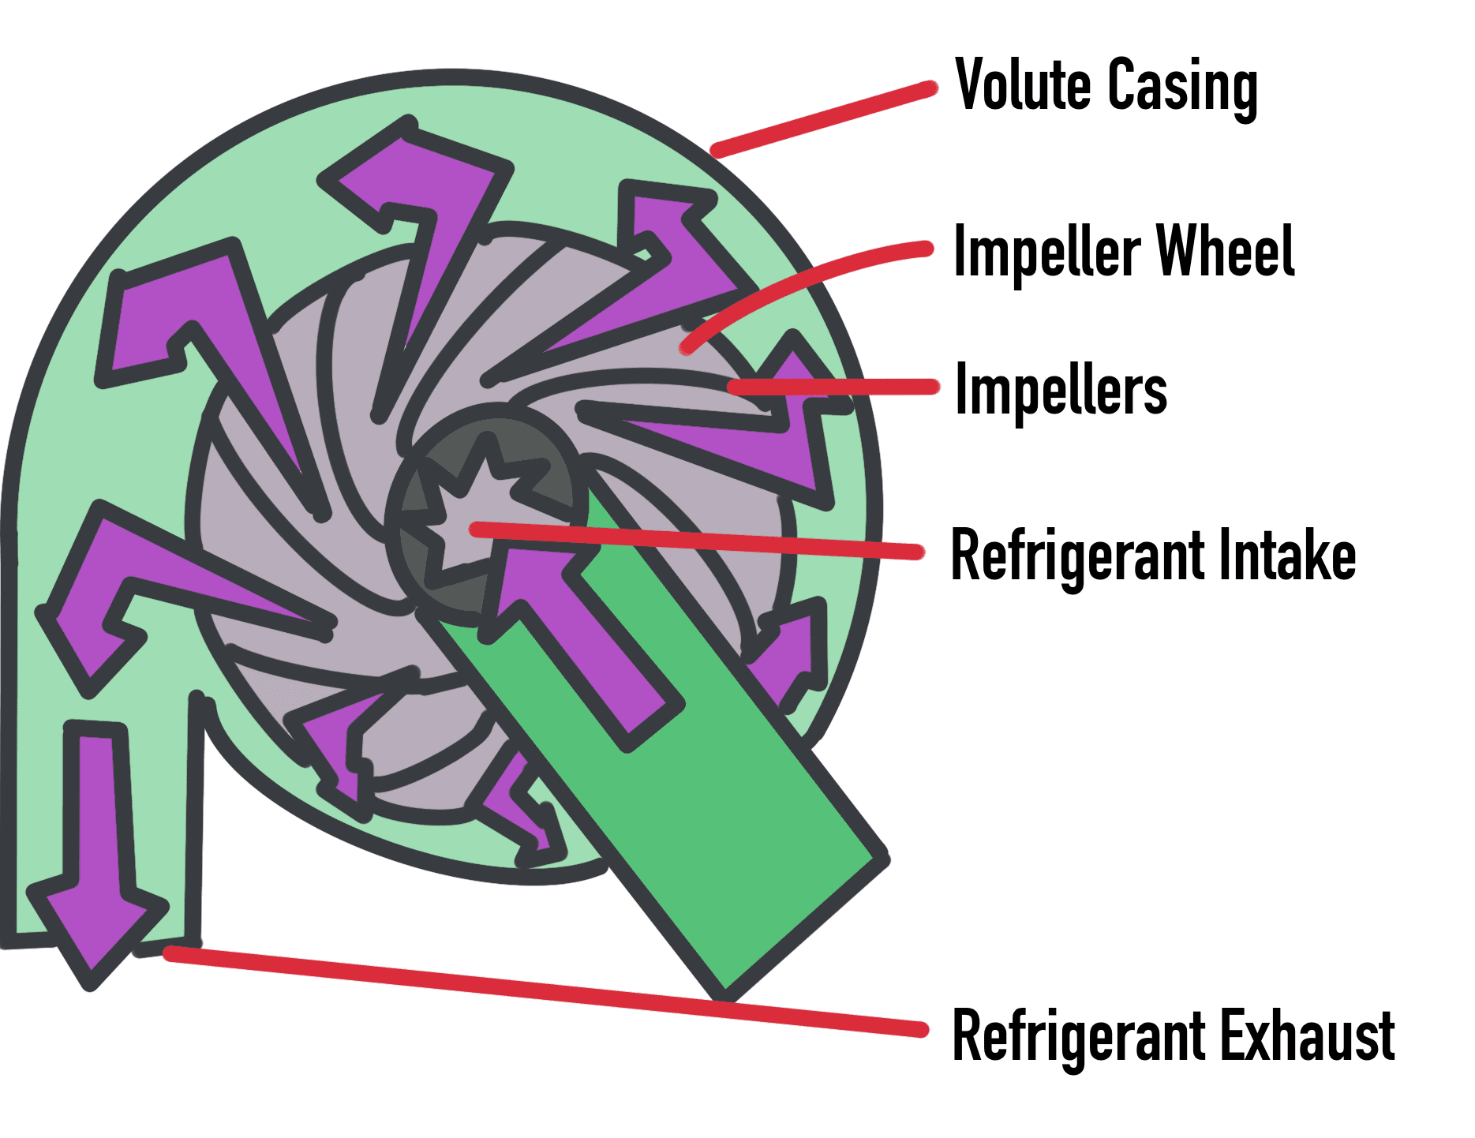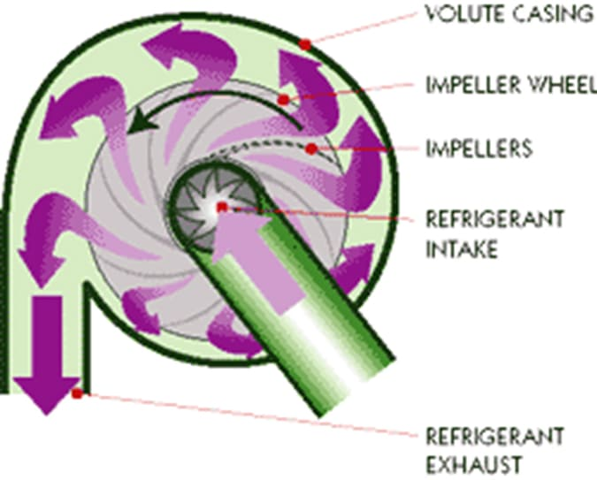Replacing a low-resolution diagram with drawing

Is there a more high-resolution diagram? Or should we redraw them?

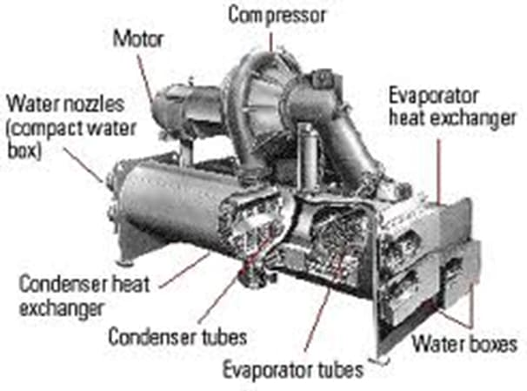

1. Mini map to show the entire areas and the user’s location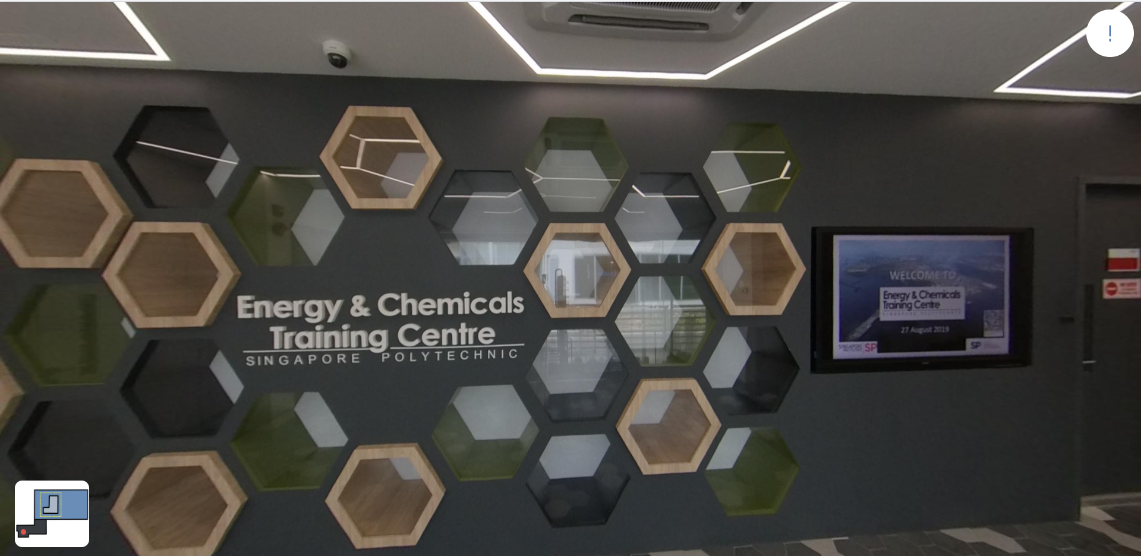

Preview of AC App:

